Quick Reads learning resources:
The Baby Is Mine by Oyinkan Braithwaite

Notes for practitioners
Quick Reads have been created specifically for adults who are less confident readers, who may not see themselves as readers or who may feel that it has been a long time since they have read. They will also appeal to younger people who feel daunted by reading their first book.

In the terms of the English adult literacy core curriculum, or Functional Skills levels, Quick Reads are often seen as suitable for those at Entry 3, Level 1 or Level 2. Adult literacy or functional skills English learners below Entry 3 may find them too challenging (as may some Entry 3 learners), but everyone is different, so it is always worth having a look.

ESOL learners – those learning or developing their English as an additional language – may also find Quick Reads a helpful introduction into reading books in English and a useful way to develop vocabulary and awareness of language structures. Quick Reads are often used by ESOL teachers teaching at Entry 3 or above. What works for individual learners will depend on the learners, their confidences, their language and literacy backgrounds, and the books themselves.

As with all resources, Quick Reads could potentially be used with a range of groups and levels, depending of course on how you use them. It is worth remembering that Quick Reads are authentic texts – real books written by real authors – and so can be particularly motivating for adult learners.

We have written these resources to be accessible for those who would find Quick Reads accessible. However, the needs, strengths and interests between and within groups vary so you may want to adapt the language at times, as well as adapt and play around with the ideas. You may find that you prefer some activities to others and that you will want to adjust them for your particular group(s) and context(s). We have therefore provided the resources as an editable Word document so that you can adapt them to be most useful.

We hope that if you do use these with your students, you try things out that you haven’t tried before, and let us – and your colleagues – know what worked well and not so well.

Tweet us @readingagency #QuickReads
Email us at readingahead@readingagency.org.uk

Find out more about Quick Reads and find book group discussion guides, promotional materials and a toolkit for promoting and using the books on The Reading Agency resources database.

The Baby Is Mine
by Oyinkan Braithwaite
About the author

Oyinkan Braithwaite gained a degree in Creative Writing and Law at Kingston University. Her first book, My Sister, the Serial Killer, was a number-one bestseller. It was shortlisted for the Women’s Prize for Fiction 2019 and was on the longlist for the Booker Prize 2019.

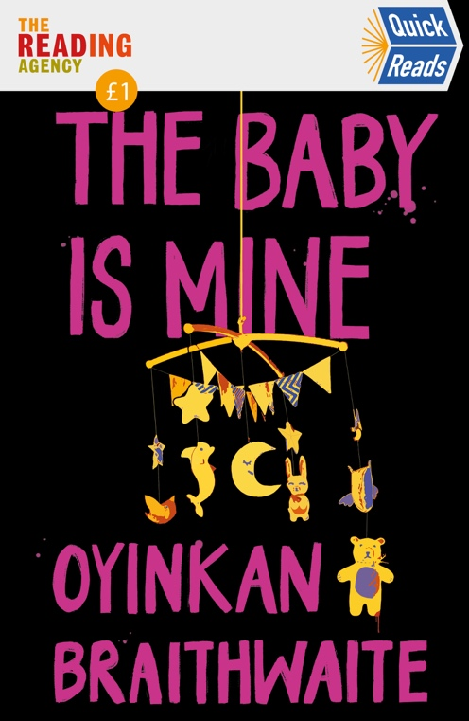
About the book

When his girlfriend throws him out during the pandemic, Bambi has to go to his Uncle’s house for lockdown in Lagos. He arrives during a blackout and is surprised to find his Aunty Bidemi sitting in a candlelit room with another woman. They both claim to be the mother of the baby boy, fast asleep in his crib. Who is lying and who is telling the truth?

Before reading:

Look at the cover of this book.
What does it make you think about?

Now read the blurb on the back of the book.
What do you think this book will be about? Why do you think so?

How could you describe the purpose of a blurb?

Is this the kind of book you would usually want to read? Why or why not?

What genre (or type) of book do you think this is? A romance? A detective book? Something else?

Chapter 1:

Where is this book set?

What do you know about Lagos? Have you ever been?

Speak to someone who has been to Lagos or use the library to try to find a book about Lagos (you could ask a librarian) and/or use the internet to search for some pictures of, or facts about, Lagos. Does this change what you think this novel could be about?

This novel is set in lockdown due to the coronavirus pandemic. What do you think that setting will add to the book? What do you think will happen?

Take a piece of paper and write ‘Bambi’ at the top or in the middle.
Note down everything you know about Bambi from this first chapter. Use your own words or note down words or phrases from the chapter.
Write down anything you suspect or are guessing about Bambi.

What did you think about this line: ‘a man was not meant to be tied to only one woman. It went against the laws of nature itself. And who was I to argue with nature?’ Do you agree? How did this line make you feel?

Chapter 2:

Take a piece of paper and note down everything we have learnt about Bambi’s grandfather’s house. Can you draw a picture of the house and the garden?

Take two more pieces of paper and write ‘Aunt Bidemi’ on one and ‘Esohe’ on the other. Do the same thing you did for Bambi. Write down what we’ve learnt about these characters. What do they look like?

Can you add any more notes to your paper on Bambi?

What adjectives would you use to describe these characters?

Chapter 3:

What do you think the relationship between Bambi and his Aunt is like?
Bambi seems uncomfortable when his Aunt starts to cry, why do you think that is?

Can you add any more notes to your description of the house?

Can you add more notes to your papers on Aunt Bidemi and Bambi?

Chapter 4:

How does the author show Aunt Bidemi’s grief, physically? Read back through Chapter 3 and Chapter 4 and note down any adjectives that describe how Aunt Bidemi’s grief can be seen.

Chapter 5:

Can you add more notes to your papers on Bambi and Esohe?

Do you think Uncle Folu is a ‘good husband’ like Bambi says?

Chapter 6:

Read Chapter 5 and Chapter 6 again and note down the way that Bambi describes women. How do you feel about the way Bambi talks about women? Do you think he respects them? Why?

Add to your notes on Bambi, Aunt Bidemi and Esohe.

We have all been in lockdown over the past year. Share your experience with your peers or tutor. Does this story remind you of your experience or not?
What would be your worst lockdown setup?

Chapter 7:

Who do you think the baby belongs to?
Find sentences from the text that back up your view.
Present your view to your peers or tutor. Think about how you can make your case clearly and what you can take from the text to get others to agree.

Chapter 8:

Have you read any other books or seen TV programmes where the characters have had to use a DNA test to find out who is the mother or father of a baby?
Do you think a DNA test should have been a priority during the pandemic?

Speak to someone who has worked in healthcare this year or have a look for newspaper articles written about healthcare workers over the past year. You could ask a librarian for help.
Does that change your answer to the last question?

Chapter 9:

Bambi is watching The Platform on Netflix. Have you watched it? If you have, what did you think of it? If you haven’t, look it up online and find out what it is about.
Why do you think the author has chosen for Bambi to watch this TV series? Is anything about it relevant to this story?

Do you think Esohe put sand in the food? If no, who do you think did?
The story talks about food a few times. Read back through Chapter 8 and 9. Why do you think the author has talked about food so much, how does it add to the story?

Read back through Chapter 7, 8 and 9 and add to your notes on Bambi, Aunt Bidemi and Esohe. Who do you think the baby belongs to now?

Chapter 10:

Why do you think Bambi refers to the baby as ‘an animal’, as well as calling him ‘it’ in previous chapters? What does this tell us about Bambi’s character?

Read back over Chapter 9 and 10. Add to your notes on Bambi’s grandfather’s house. How do the descriptions of the setting add to the story?

What do you think about the tribal marks given to the baby?

Who holds the power in this chapter? What does this tell us?

Chapter 11:

Do you think Bambi and Remi’s relationship is changing? Why?

Describe Bambi and his sister’s relationship. Do you have any siblings? Is your relationship similar or different to them?

Chapter 12:

Bambi says: ‘when I returned Remi to his mother’ in the first line of this chapter. Who did you imagine when he said this? Why do you think the author worded it like this?

Why do you think the author has included the cock in the story? Can you remember any other descriptions of animals in the book so far?

Go back to your notes on who you thought the mother of the baby was after Chapter 7. Do you agree with your view? Add to your notes now that you have more information.

Chapter 13:

Bambi is shocked by seeing his Aunt breastfeeding and then shocked by seeing Esohe kill the cockerel. Would these actions shock you? Do you think Bambi is right to be shocked?

Read back through Chapter 10, 11, 12 and 13 and add to your notes on Bambi, Aunt Bidemi and Esohe. Which character do you trust the most? Why?

Chapter 14:

What do you know about Yoruba culture? If you haven’t heard of it ask someone else or google it!

What can insults add to a text? How did the word ‘slut’ make you feel?

Chapter 15:

What do you think of social media? Do you use it?

What did the sentence ‘mothers are all clearly unhinged’ make you feel? Do you agree?

Chapter 16:

Do you believe in witchcraft?

What does the darkness add to this scene? Does it make the setting more scary?

Chapter 17:

What does Esohe and Bambi’s encounter tell you about how Esohe is feeling?

What do you think about the way Bambi spoke to Mide? Was Mide right to kick him out?

Read back through Chapter 14, 15, 16 and 17 and add to your notes on Bambi, Aunt Bidemi and Esohe.

Chapter 18:

Do you think anyone is being selfish? Who and why?

What do you think Bambi’s drinking and medication taking says about his state of mind?

Chapter 19:

Do you judge people by which football teams they support?

‘Babies all looked the same to me. They had eyes that were always closed, no eyebrows, barely any hair. They never looked please to be here. They came in different colours, but that was about it.’ Do you agree with Bambi?

Read back through Chapter 18 and 19 and add to your notes on Bambi, Aunt Bidemi and Esohe.

Chapter 20:

Do you think Remi is changing Bambi’s personality? If yes, how is he changing and why do you think he is?

Do you feel sorry for Esohe? Do you think she deserves to be locked away?

Bambi says to Bukky: ‘You’re a better person than me, Buks. You always have been. But I don’t think this is the time for honesty.’ Do you think he’s right?

Do you know what ‘gaslighting’ is? Look up the word online and discuss whether you think it is relevant to this chapter.

Chapter 21:

Do you think this house resembles a prison in any way? Try and find examples to support your answer.
Go back through the chapter and re-write it from Esohe’s perspective. What do you think she’s feeling whilst she’s locked in her room?

Chapter 22:

Do you believe Esohe?

Do you know what prejudice is? Do you think Bambi has been prejudiced towards Esohe?

Chapter 23:

Have you read any romantic books before? What were they and what did you think? Do you think this book is a romance?

Why do you think Esohe accepted that Remi is Aunt Bidemi’s child? Do you think this is the truth?
Read back through Chapter 20, 21, 22 and 23. Add to your notes on Bambi, Aunt Bidemi and Esohe to help answer this question.

Chapter 24:

Have you ever meditated? What did you think of it, was it similar to Bambi’s description or different?

Who has the power in this chapter? Has there been a shift?

Who do you like the most in the story? Why?

Chapter 25:

This chapter is a memory of another time. Did you know that straight away? What made you realise that it was a memory?

What does going back in time add to the story?

Chapter 26:

Read back through Chapter 24, 25 and 26 and your notes on Bambi, Aunt Bidemi and Esohe.
Who do you think Remi/Efosa belongs to now?

Do you know anyone who gave birth during lockdown? Was it similar to Esohe’s story?

What role do you think love plays in this story?

Can you understand the actions of Aunt Bidemi? Do you feel sympathy for her?

Chapter 27:

Is Bambi becoming more helpful? Why?

Do you think Remi/Efosa is being well looked after?

Chapter 28:

Do you think Bambi is right to take the child?

What do you think is affecting Aunt Bidemi’s actions?

Do you think Mide will take Bambi back? Do you think she should?

After finishing the book:

- Go back and find your favourite sentence in this book. Think or talk about why you chose that sentence.
- Go back and try to imagine what Mide’s lockdown might have been like. Try and write a paragraph about how she might have felt when she kicked Bambi out.
- Do you think sexism has a part to play in this book? Find any sentences that stand out to you as sexist and discuss them.

