Quick Reads learning resources:
The Skylight by Louise Candlish

Notes for practitioners
Quick Reads have been created specifically for adults who are less confident readers, who may not see themselves as readers or who may feel that it has been a long time since they have read. They will also appeal to younger people who feel daunted by reading their first book.

In the terms of the English adult literacy core curriculum, or Functional Skills levels, Quick Reads are often seen as suitable for those at Entry 3, Level 1 or Level 2. Adult literacy or functional skills English learners below Entry 3 may find them too challenging (as may some Entry 3 learners), but everyone is different, so it is always worth having a look.

ESOL learners – those learning or developing their English as an additional language – may also find Quick Reads a helpful introduction into reading books in English and a useful way to develop vocabulary and awareness of language structures. Quick Reads are often used by ESOL teachers teaching at Entry 3 or above. What works for individual learners will depend on the learners, their confidences, their language and literacy backgrounds, and the books themselves.

As with all resources, Quick Reads could potentially be used with a range of groups and levels, depending of course on how you use them. It is worth remembering that Quick Reads are authentic texts – real books written by real authors – and so can be particularly motivating for adult learners.

We have written these resources to be accessible for those who would find Quick Reads accessible. However, the needs, strengths and interests between and within groups vary so you may want to adapt the language at times, as well as adapt and play around with the ideas. You may find that you prefer some activities to others and that you will want to adjust them for your particular group(s) and context(s). We have therefore provided the resources as an editable Word document so that you can adapt them to be most useful.

We hope that if you do use these with your students, you try things out that you haven’t tried before, and let us – and your colleagues – know what worked well and not so well.

Tweet us @readingagency #QuickReads
Email us at readingahead@readingagency.org.uk

Find out more about Quick Reads and find book group discussion guides, promotional materials and a toolkit for promoting and using the books on The Reading Agency resources database.

The Skylight
by Louise Candlish

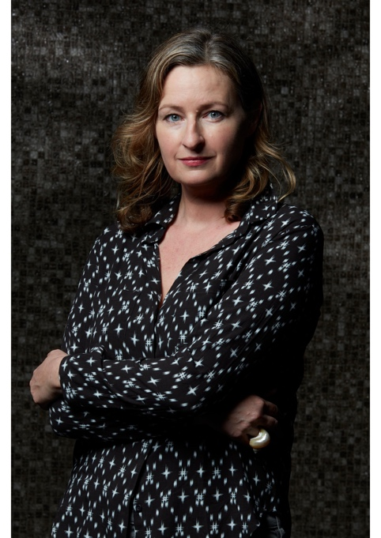
About the Author

Louise Candlish is the Sunday Times bestselling author of The Other Passenger and thirteen other novels. Our House won the Crime & Thriller Book of the Year at the 2019 British Book Awards. It is now in development for a major TV series. Louise lives in London with her husband and daughter.

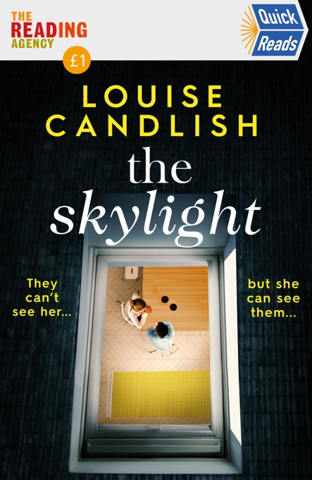
About the Book

When Simone looks through the skylight into the flat below hers, she sees her boyfriend Jake sipping wine with their attractive young neighbour Alina, even though he’d claimed he was working late. The sight of the two of them together triggers a violent desire to teach them a lesson they won’t forget.

Before reading:
Read the title of the book. How does this title make you feel?
Look at the cover and read about the author on the very first page inside the cover. What do you think this book is going to about?
What type of book do you think this is? Romance, crime, horror?
Does it look like any other books that you’ve seen or read before?
Chapter 1:

Has anyone ever cancelled plans with you last minute? How did this make you feel?

Simone is only in contact with one member of her family, can you think of reasons why this might be?

Simone describes Alina and Gus’ life as ‘the perfect life.’ Read back through the chapter and make a note of everything Alina thinks makes their life ‘perfect.’ Do you agree with her?

Would you spy on your neighbours if you were in Simone’s position?

How would you feel seeing Jake in Alina’s apartment if you were Simone?

Chapter 2:

What would you do if you were Alina at this moment?

Read back through Chapter 1 and 2 and write down everything you have learnt about Simone so far.
What have you learnt about Simone’s family backstory in this chapter?

Why do you think Simone doesn’t tell Jake that she saw him in Alina’s flat?

Chapter 3:

Do you agree that ‘even beautiful people can look ugly when they do bad things’?
Have you ever heard of The Twits by Roald Dahl? If you haven’t, you could look for it in the library or find out about the book online. Why is the book relevant to that statement?

How do you feel about Simone stealing Alina’s mail?

What do you think Simone could be planning for Jake and Alina?

Chapter 4:

What do you think Alina’s middle name could be? Think of 10 names that begin with ‘F.’

What is Simone’s plan? Find examples from the text to help with your answer.

Simone takes care to make sure she won’t be caught. Read back through the Chapter and make a list of all the actions she does to cover her tracks.
Do you think she has thought of everything?

How far do you think betrayal can push a person? Have you ever been made to feel betrayed or lied to?

Who do you think the note is from? Do you think it was meant for Simone?

Chapter 5:

Read back through Chapter 3, 4 and 5 and pick out all the different types of nuts mentioned in the text. Have you heard of them all before? Can you add anymore types that you know of?

What do you think could have happened to Simone’s Dad?

Do you think it is fair that Simone is only seeking revenge on Alina so far? Do you think Jake is equally to blame?

Why do you think Simone is recording Alina and Jake?

Chapter 6:

Did the line ‘she’s never told a soul about what I did when I was eleven’ make you want to keep reading? What do you think Simone did?

Use the internet to find out some other foods that people are allergic to in the UK, which are the most common allergies?

Do you agree with Simone that Jake is right for her?

Imagine that Simone phones Jake to tell him what has happened. Try to write down what they might say to each other.

Chapter 7:

The title of the Chapter is ‘sad news.’ What do you think has happened to Gus?

How do you think Simone would describe the story to her colleagues? Try to write a paragraph that describes Simone telling her colleagues what happened that morning.

Read through the Chapter again and make a note of everything that Simone does to cover her tracks.
Do you think Simone will be suspected?

Do you feel sorry for any of the characters in the story? Who and why?

Chapter 8:

Chapter 8 is called ‘Police questions.’ Can you think of the first 5 questions the police might ask Simone? Write the questions down and try and answer them as if you are Simone. What would she say?

Do you know who Agatha Christie is? If not, you could ask a librarian or search online. Why does Alina describe the situation as ‘like something out of an Agatha Christie’?
Try and find the section in the library that has books by Agatha Christie. Read the blurb of the some of the books.

What is a ‘motive’? Look up the word in the dictionary and find a definition.
Do you think any of the motives that Simone suggests are believable?

Chapter 9:

Read page 51 again. Why do you think Simone takes the fern from the middle of the table and puts a vase of roses there instead?

Read Chapter 9 again and try to write a tribute as if you knew Gus. What have you learnt about him so far that you can include?

Do you think Alina is obsessed with appearing ‘perfect’? Try and find examples in the text.

Do you think Jake will catch out Simone? Make a note of the mistakes she makes in the chapter that might make Jake suspicious.

Why do you think Simone needs to see Paula?

Chapter 10:

Do you agree with Paula that you ‘have to have some sympathy’ for Alina?

Have you ever made lasagna? Find a recipe book in the library or look up a recipe online and copy out the ingredients list and recipe. Go shopping for the ingredients and try cooking a lasagna!

What did you want to be when you grew up?

Find your notes from Chapter 6 about the line, ‘she’s never told a soul about what I did when I was eleven.’ Can you add to your notes? Do you have any more ideas about what Simone might have done?

Chapter 11:

How does the author show Alina’s grief?
Read the chapter again and make a note of the everything that has changed about Alina and her apartment since Chapter 1.

Chapter 11 is called ‘A Warning for Alina.’ What does Simone say that Alina should see as a warning?
Who do you think is more at fault in this story? Would you feel the same if it was real life? Why/Why not?

Try and write a paragraph from Jake’s point of view. What do you think he is saying to Alina in this chapter?

Chapter 12:

Write down all the reasons Alina and Jake found out what Simone did. Do you think she could have done anything differently to make sure they didn’t find out?

Do you know who Sherlock Holmes is? If not, you could ask a librarian or search online. Why does Simone describe Jack as ‘Sherlock Holmes’?
Try and find the section in the library that has books about Sherlock Holmes. Who wrote them?

Do you know what the word ‘pious’ means? Look it up in the dictionary and find a definition.

Do you believe Jake when he says that he won’t tell anyone what Simone did?

Why does Simone say that it is a third chance?

Chapter 13:

Imagine that Alina’s flat is for sale in a newspaper. Write an advert to sell the flat. Describe the layout, what the flat looks like and what type of person might like to live there.
Find a newspaper in the library or search online and look up adverts for flats for sale. Choose one that you think would be most similar to Alina’s. Explain why you chose that one.

Why do you think Paula wanted Simone to read ‘Suzi’s story’?

Find your notes from Chapter 6 and Chapter 10 about the line, ‘she’s never told a soul about what I did when I was eleven.’ What did Simone do when she was eleven? Were your ideas correct?

Chapter 14:

Have you ever been to Italy? Ask a librarian to show you a travel guide for Italy. Can you find any pictures of lakes like the one Simone describes on page 85?

What did Paula mean when she told Simone that she should ‘give people the benefit of the doubt’? Do you agree?

What is your opinion on Jake? Do you think he was right to turn Simone in? Were you expecting him to turn Simone in?

Do you know what the word ‘ironic’ means? Look it up in a dictionary and find a definition. Can you think of another example of something ‘ironic’?

Acknowledgements

Why has the author included a page for ‘acknowledgments’ at the end of the book?

Imagine you had written this book. What would write on the ‘acknowledgments’ page?

After finishing the book:

- Write a list of the flaws of Alina, Simone and Jake. Who do you think was most in the wrong?
- With a partner or on your own, write a letter to Simone explaining how she could have taught Alina and Jake a lesson without committing murder.
- What do you think were Simone’s main mistakes that gave her away to Jake?
- Were you happy with the way this book ended? Did you want Simone to get away with it? Why?

