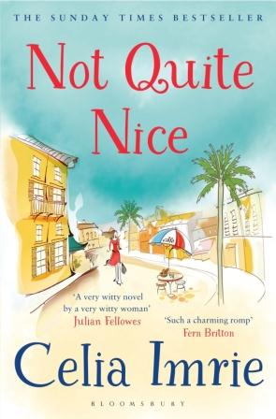
NOT QUITE NICE
Reading Group Questions

‘Utterly delicious in every way’ – Joanna Lumley
‘Such a charming romp’ – Fern Britton

About Not Quite Nice
Theresa is desperate for a change. Forced into early retirement, tired of babysitting her bossy daughter’s obnoxious children, she sells her house and moves to a picture-perfect town, just outside Nice.
Once the hideaway of artists and writers, Bellevue-Sur-Mer is now home to the odd movie star and, as Theresa discovers, a close-knit set of expats. Settling to the gentle rhythm of the seaside, Theresa embraces her new-found friendships and freedom. But life is never as simple as it seems, and when skeletons fall out of several closets, Theresa starts to wonder if life on the French Riviera is quite as nice as it first appeared …

Questions for discussion
- How would you describe NOT QUITE NICE in 5 words?

- Which of the eccentric Bellevue-sur-Mer residents is your favourite, and why? Do you identify with any of them in particular?

- ‘Vivid purples, pinks and reds of bougainvillea and oleander bushes crowded under the green boughs of umbrella pines, orange trees and palms, and all set against the turquoise and ultra-marine background which was the sea and sky.’ The French Riviera almost becomes another character in the book. What is it about the setting of the novel that holds so much appeal?

- Theresa ready for a change and new challenges. Do you feel sympathetic to her desires for a new life? Discuss the theme of ‘second chances’ in the book

- Food is Theresa’s great passion. What is it about gastronomy and France that

- Discuss the parent child relationships in the book. Can you identify with the challenges of family life?

- Celia Imrie had always wanted to turn her hand to writing a novel. Have you ever been tempted to do the same?

