Reading Well Books on Prescription

Library website copy

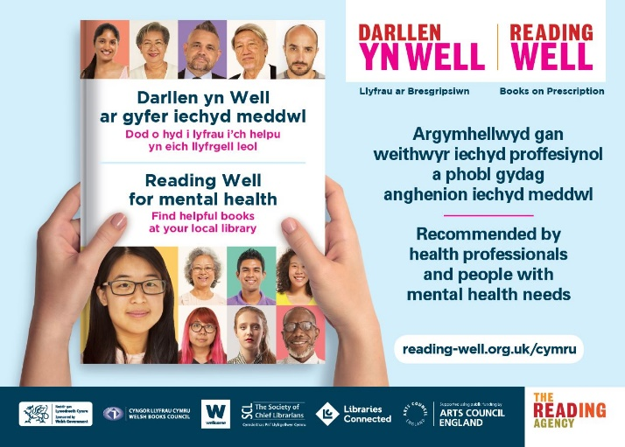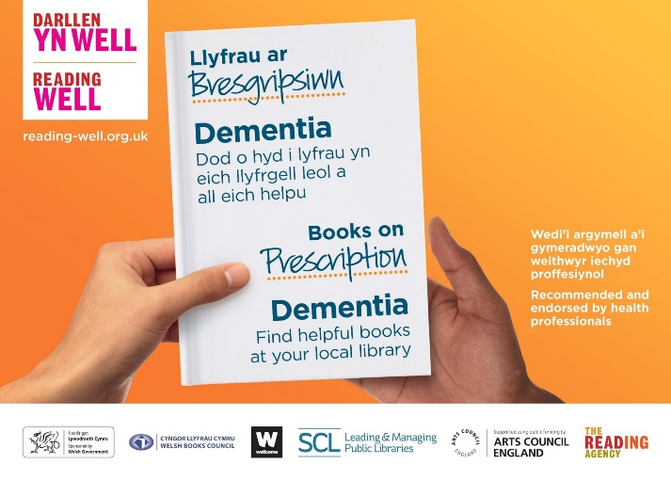

Reading Well Books on Prescription supports you to understand and manage your health and wellbeing using helpful reading. The books are all recommended by health experts, as well as by people with living with the conditions and topics covered and their relatives and carers. The books are available for anyone to borrow from the local library. You can also be recommended a title by a health professional to support treatment. The books are available in both English and Welsh.

Many of the Reading Well titles are available to borrow as e-books and audiobooks. [INSERT YOUR LIBRARY E-LENDING ACCESS INFORMATION HERE – THE FULL LIST OF E-LENDING AVAILABILITY IS AVAILABLE TO DOWNLOAD HERE.]

Since 2013, Reading Well Books on Prescription has reached over 1.2 million people in England and Wales and 90% of people surveyed have found their book helpful.

There are two booklists currently available in Welsh public libraries:

- Reading Well Books on Prescription for mental health
Reading Well for mental health provides helpful information and support for managing common mental health conditions, or dealing with difficult feelings and experiences. Some books also include personal stories from people who are living with or caring for someone with mental health needs.

Browse the bilingual digital leaflet here and a full overview of the titles here.

- Reading Well Books on Prescription for dementia
Reading Well for dementia provides information and advice for people living with dementia, support for living well, advice for relatives and carers, as well as fiction, memoir and photographic books used in reminiscence therapy.

Browse the digital leaflet in Welsh or English and a full overview of the titles here.

Visit reading-well.org.uk/wales to find out more about Reading Well. You can also watch the video below to hear more about the impact of the scheme from broadcaster Beti George and author Sharon Marie Jones:

Film in English

[COPY THE FOLLOWING CODE TO EMBED THE ENGLISH VIDEO INTO YOUR WEBSITE]:

<iframe width="560" height="315" src="https://www.youtube.com/embed/Evk6HyzuShw" frameborder="0" allow="accelerometer; autoplay; encrypted-media; gyroscope; picture-in-picture" allowfullscreen></iframe>

Film in Welsh

[COPY THE FOLLOWING CODE TO EMBED THE WELSH VIDEO INTO YOUR WEBSITE]:

<iframe width="560" height="315" src="https://www.youtube.com/embed/oKohPUwcYlQ" frameborder="0" allow="accelerometer; autoplay; encrypted-media; gyroscope; picture-in-picture" allowfullscreen></iframe>

Reading Well is delivered by The Reading Agency in partnership with Welsh public libraries and funded by Welsh Government. It is available in all 22 library authorities in Wales.

Darllen yn Well Llyfrau ar Bresgripsiwn

Copi gwefan Llyfrgell

Mae Darllen yn Well Llyfrau ar Bresgripsiwn yn eich cefnogi i ddeall a rheoli eich iechyd a’ch lles trwy ddarllen defnyddiol. Mae'r llyfrau i gyd yn cael eu hargymell gan arbenigwyr iechyd, yn ogystal â phobl sy'n byw gyda'r cyflyrau a'r pynciau dan sylw a'u perthnasau a'u gofalwyr. Mae'r llyfrau ar gael i unrhyw un eu benthyg o'r llyfrgell leol. Gall gweithiwr iechyd proffesiynol hefyd argymell teitl i chi er mwyn cefnogi triniaeth. Mae'r llyfrau ar gael yn Gymraeg ac yn Saesneg.

Mae llawer o deitlau Darllen yn Well ar gael i'w benthyg fel e-lyfrau a llyfrau llafar. [NODWCH EICH GWYBODAETH MYNEDIAD E-FENTHYG LLYFRGELL YMA – GELLIR LAWRLWYTHO'R RHESTR GYFLAWN O’R LLYFRAU SYDD AR GAEL I'W E-FENTHYG YMA.]

Ers 2013, mae Darllen yn Well Llyfrau ar Bresgripsiwn wedi cyrraedd dros 1.2 miliwn o bobol yng Nghymru a Lloegr a dywed 90% o ddarllenwyr bod eu llyfr wedi bod yn ddefnyddiol iddyn nhw.

Mae dwy restr lyfrau ar gael ar hyn o bryd yn llyfrgelloedd cyhoeddus Cymru:

- Darllen yn Well Llyfrau ar Bresgripsiwn ar gyfer iechyd meddwl
Mae Darllen yn Well ar gyfer iechyd meddwl yn darparu gwybodaeth ddefnyddiol a chefnogaeth ar gyfer rheoli cyflyrau iechyd meddwl cyffredin, neu ddelio â theimladau a phrofiadau anodd. Mae rhai llyfrau hefyd yn cynnwys straeon personol gan bobl sy'n byw gyda neu'n gofalu am rywun ag anghenion iechyd meddwl.

Gallwch bori drwy'r daflen ddigidol ddwyieithog yma a gweld trosolwg llawn o'r teitlau yma.

- Darllen yn Well Llyfrau ar Bresgripsiwn ar gyfer dementia
Mae Darllen yn Well ar gyfer dementia yn darparu gwybodaeth a chyngor i bobl sy'n byw gyda dementia, cefnogaeth i fyw'n dda, cyngor i berthnasau a gofalwyr, yn ogystal â ffuglen, cofiannau a llyfrau ffotograffig a ddefnyddir mewn therapi hel atgofion.

Gallwch bori drwy'r daflen ddigidol yn Gymraeg neu Saesneg a throsolwg llawn o’r teitlau yma.

Ewch i reading-well.org.uk/cymru i ddarganfod mwy am Darllen yn Well. Gallwch hefyd wylio'r fideo isod i glywed mwy am effaith y cynllun gan y ddarlledwraig Beti George a’r awdur Sharon Marie Jones:

Ffilm Saesneg

[COPIWCH Y COD CANLYNOL ER MWYN MEWNOSOD Y FIDEO SAESNEG I’CH GWEFAN ]:

<iframe width="560" height="315" src="https://www.youtube.com/embed/Evk6HyzuShw" frameborder="0" allow="accelerometer; autoplay; encrypted-media; gyroscope; picture-in-picture" allowfullscreen></iframe>

Ffilm Gymraeg

[COPIWCH Y COD CANLYNOL ER MWYN MEWNOSOD Y FIDEO CYMRAEG I’CH GWEFAN ]:

<iframe width="560" height="315" src="https://www.youtube.com/embed/oKohPUwcYlQ" frameborder="0" allow="accelerometer; autoplay; encrypted-media; gyroscope; picture-in-picture" allowfullscreen></iframe>

Caiff Darllen yn Well ei gyflenwi gan The Reading Agency mewn partneriaeth a llyfrgelloedd cyhoeddus Cymru ac fe’i ariennir gan Lywodraeth Cymru.

