Reading Well library website copy

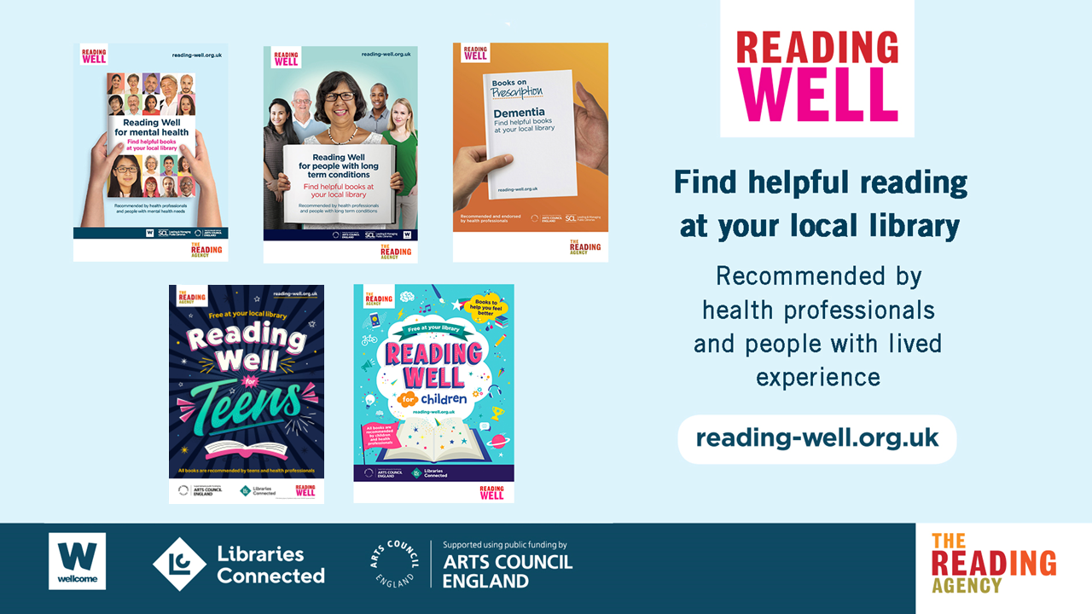

Reading Well supports you to understand and manage your health and wellbeing using helpful reading. The books are all chosen and recommended by health experts, as well as by people with living with the conditions and topics covered, and their relatives and carers. The books are available for anyone to borrow from the local library. You can also be recommended a title by a health professional to support treatment.

Many of the Reading Well titles are available to borrow as e-books and audiobooks. [INSERT YOUR LIBRARY E-LENDING ACCESS INFORMATION HERE – THE FULL LIST OF E-LENDING AVAILABILITY IS AVAILABLE TO DOWNLOAD HERE.]

Since 2013, Reading Well Books on Prescription has reached over 3.3 million people and 90% of people surveyed have found their book helpful.

There are five booklists currently available in [INSERT YOUR LIBRARY SERVICE + DELETE LISTS AS APPROPRIATE]:

Reading Well for mental health
Reading Well for mental health provides helpful information and support for managing common mental health conditions, or dealing with difficult feelings and experiences. Some books also include personal stories from people who are living with or caring for someone with mental health needs.

Browse the digital leaflet here and find out more about the titles here.

Reading Well for teens
Reading Well for teens suggests recommended reading and digital resources to help teenagers (13-18) better understand their feelings, handle difficult experiences and boost confidence. The list is focused on supporting teens’ mental health and wellbeing in a post-pandemic context.

Browse the digital leaflet here and find out more about the titles here.

Reading Well for children
Reading Well for children provides quality-assured information, stories and advice to support children’s mental health and wellbeing. It covers general information and advice about understanding and managing feelings, school and online pressures, bereavement, parental mental health needs, and living well with specific diagnosed conditions and physical disabilities.
The booklist is targeted at children in Key Stage 2 (aged 7-11), but includes titles aimed at a wide range of reading levels to support less confident readers, and to encourage children to read together with their siblings and carers.
Browse the digital leaflet here and find out more about the titles here.

Reading Well for long term conditions
Reading Well for long term conditions provides information and support for people living with a long term health condition and their carers. The booklist covers general advice and information about living with a long term condition, common symptoms and titles focused on specific conditions such as arthritis, bowel conditions, diabetes, heart disease and stroke.
Browse the digital leaflet here and find out more about the titles here.

Reading Well for dementia
Reading Well for dementia provides information and advice for people living with dementia, support for living well, advice for relatives and carers, as well as fiction, memoir and photographic books used in reminiscence therapy.

Browse the digital leaflet here and find out more about the titles here.

Visit reading-well.org.uk to find out more about Reading Well. If you have read a Reading Well book, tell us what you thought for the chance to win a prize at reading-well.org.uk/feedback.

The programme is delivered by The Reading Agency in partnership with Libraries Connected as part of the Libraries Connected Universal Health Offer.

