5. Every picture tells a story

Overview

Uses visual literacy to improve spoken and written language skills.

Student targets

Entry 1

Listen and be able to complete exercise

Learn basic vocabulary

Entry 2

Listen and complete the exercise

Speak clearly to be understood

Be able to write a short sentence under each panel to explain the story

Entry 3

Listen and complete the exercise

Speak clearly to be understood.

Be able to write short summary of the story of What happened to John based on that they drew

What happened to John?

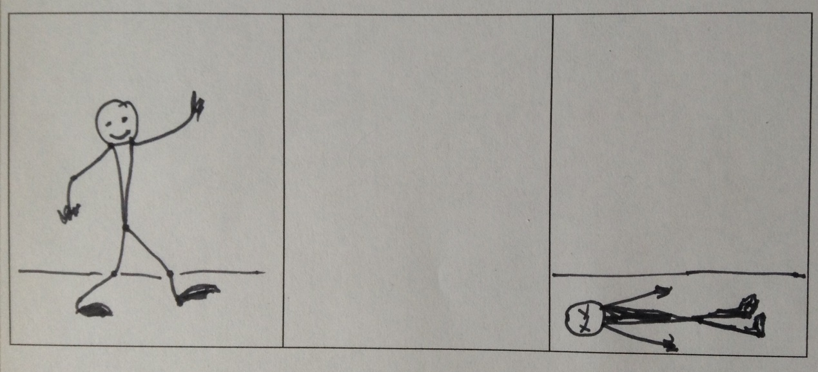

Each student is given a copy of the three panels. Explain that the story reads left to right: we see John start walking but in the third panel he is lying on the floor.

Each student must complete the middle panel and so decide what led to that final panel. The class can then show each other the different ways they have completed the story. Each student must then write beneath the panels what happened to John.

Notes
Generally John is killed or injured in some bizarre way. The exercise allows the students to reach for more expressive vocabulary that follows their own creative thoughts. Each student will have completed a short illustrated story. The vocabulary and phrases can be pooled for the whole class to use in future exercises.

