INSERT DATE of release: Join [organisation and location] for a very special event on [insert date] to mark World Book Night, an annual celebration of reading which aims to reach people who don’t regularly pick up a book.
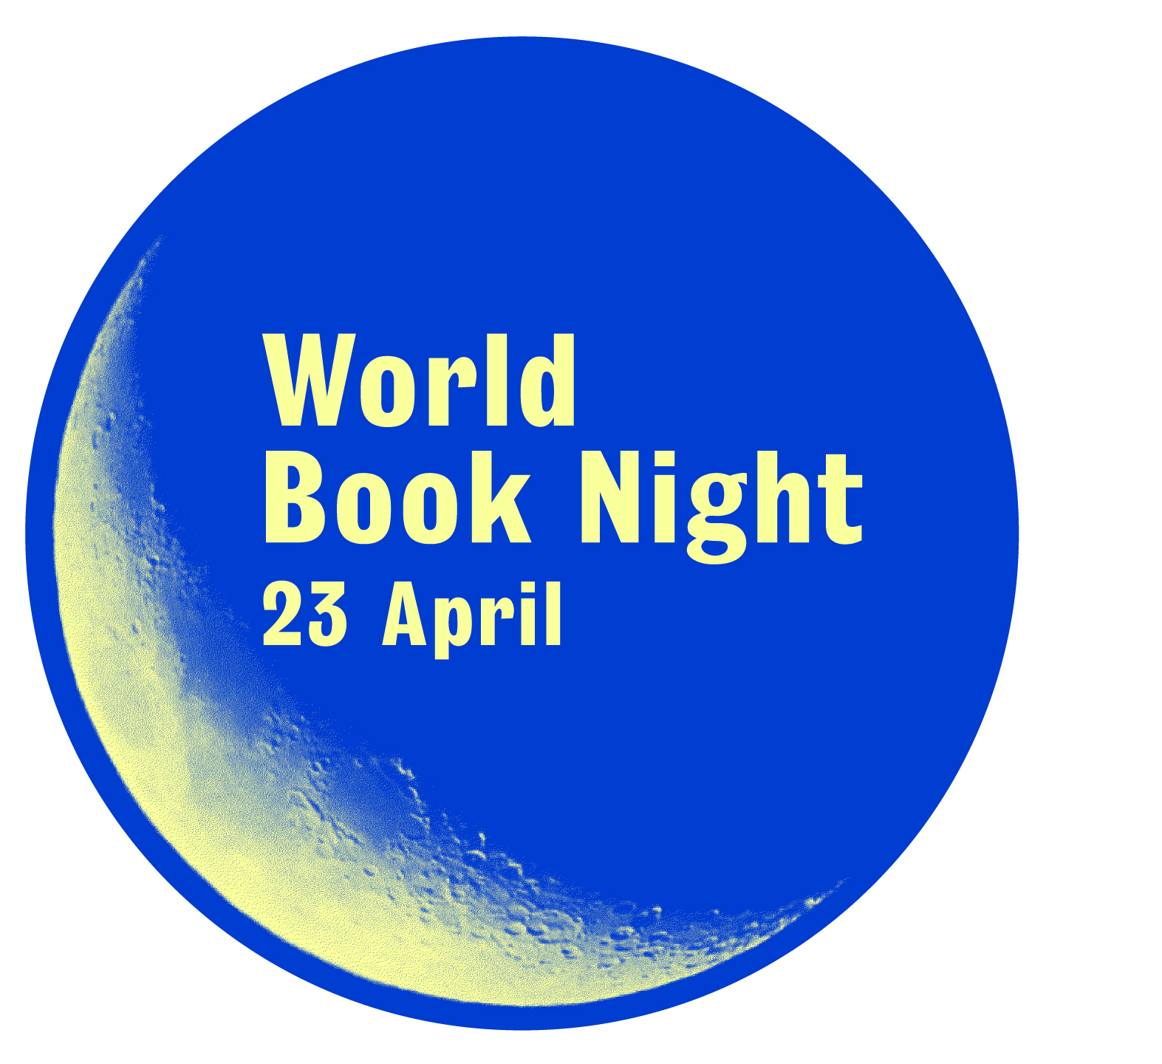
The event, taking place at [organisation and location] at [time], will feature special guest [give details of special guests or authors]. Visitors [of all ages] can get involved in [insert details of event here]

Run every 23 April by national charity The Reading Agency, World Book Night is committed to reaching the millions of people in the UK who don’t regularly read for pleasure or own books.

Alongside events taking place nationwide, this year World Book Night is encouraging readers across the UK to celebrate reading by sharing a book that has made a difference to them. Give out your own book of choice in your community and post it on the World Book Night 2017 Goodreads page, or take part on social media on 23 April by recommending a book that has made a difference to you, using #WorldBookNight.

Research from The Reading Agency has shown that reading for pleasure is a more powerful factor in life achievement than socio-economic background and can contribute to positive mental health. Nearly two thirds (64%) of those who received a book on World Book Night 2016 said it encouraged them to read more, while 88% of those who gave out books said they had talked about books more since taking part.

[Insert quote from e.g. head of organisation, local councillor]

David Almond, author, says: “What a great, optimistic, liberating, democratic project. What a wonderful way to celebrate one of humankind’s greatest creations. What a truly creative way to encourage people to read one book, then another, then another, to encourage people to become lifelong readers. The Reading Agency and World Book Night are forces for development and change. They really are helping to create a better world.”

Event details

- Name of event
- Venue name
- Location
- Full details on event
- Any ticket purchasing info

This year World Book Night will also work closely with specially selected organisations such as care homes, youth centres, colleges, prisons, public libraries, mental health groups and other charities to match books with new readers.

Publishers have donated the following books:
The Bones of Grace by Tahmima Anam (Canongate)
Payback by Kimberley Chambers (Harper)
Raven Black by Ann Cleeves (Pan Macmillan)
A Very Distant Shore by Jenny Colgan (Orion) Quick Reads
Streets of Darkness by A. A. Dhand (Transworld)
The Beach Café by Lucy Diamond (Pan Macmillan)
Faded Glory by David Essex (Head of Zeus)
Mr Loverman by Bernardine Evaristo (Penguin General)
Bridget Jones: Mad About the Boy by Helen Fielding (Vintage)
The Traitor (Carnivia Trilogy) by Jonathan Holt (Head of Zeus)
False Nine (Scott Manson series) by Philip Kerr (Head of Zeus)
The Unexpected Inheritance of Inspector Chopra by Vaseem Khan (Hodder & Stoughton)
Orangeboy by Patrice Lawrence (Hachette Children’s)
The Secret Marriage Pact by Georgie Lee (Mills & Boon)
Sofia Khan is Not Obliged by Ayisha Malik (Bonnier Zaffre)
Animal Kingdom by Millie Marotta (Pavilion)
The Good Son by Paul McVeigh (Salt)
One False Move by Dreda Say Mitchell (Hodder & Stoughton) Quick Reads
Wonder by R. J. Palacio (Penguin Random House Children’s)
The Last Act of Love by Cathy Rentzenbrink (Pan Macmillan)
Persepolis by Marjane Satrapi (Vintage)
The Girl Who Wasn’t There by Ferdinand von Schirach (Little, Brown)
Of Mice and Men by John Steinbeck (Penguin General)
Lies We Tell Ourselves by Robin Talley (Harlequin)
The Missing by C. L. Taylor (Avon)
The Secret Diary of Hendrik Groen Aged 83 ¼ - Anonymous (Michael Joseph)

Get involved
Take part in World Book Night by attending an event or giving a book of your own to someone in your community. Let us know what you’re doing by following World Book Night on Twitter or Facebook (@worldbooknight), or following all the news on www.worldbooknight.org.

Join the World Book Night Goodreads community at https://www.goodreads.com/list/show/105983.World_Book_Night_2017

Full details of countrywide events will be available here.

For all media enquiries please contact Stand Agency at readingagency@standagency.org.uk Tel: 0203 6965800

Notes to editors
The authors: Many of the title authors are lending their support to the campaign, and may be available for interview. Please send all interview requests to Stand Agency at readingagency@stand.org.uk or call 0203 6965800.

World Book Night is an annual celebration of reading and books, run by The Reading Agency, which takes place on 23 April, Shakespeare’s birthday and UNESCO Day of the Book. You can read Free Thought Research’s impact report on World Book Night at www.worldbooknight.org/impact

The Reading Agency is the leading national charity inspiring people of all ages and backgrounds to read for pleasure and wellbeing. Working with partners such as the public library service, our aim is to make reading accessible to everyone. The Reading Agency is funded by the Arts Council.www.readingagency.org.uk

WORLD BOOK NIGHT PARTNERS AND SUPPORTERS

- Quick Reads, now part of The Reading Agency, aims to bring the pleasures and benefits of reading to everyone, including the one in three adults in the UK who do not regularly read for pleasure, and the one in six adults in the UK who find reading difficult. Each year big name authors are commissioned to write short books that are specifically designed to be easy to read. Since 2006, 4.8 million books have been distributed through the initiative, 4.6 million library loans (PLR) have been registered and through outreach work hundreds of thousands of new readers each year have been introduced to the joys and benefits of reading.

- The World Book Night books are produced in the UK by Clays, part of St Ives PLC, and CPI Books. Clays were established over 200 years ago and recognised as a market leading book production specialist, printing over 140 million books every year. CPI Books are a division of CPI Group, Europe’s leading digital and litho book printer, with a manufacturing presence in seven European countries, including the UK, France, Germany, Spain and the Czech Republic.
- Other partners include: BBC, The Publishers’ Association, The Booksellers’ Association of UK and Ireland, Society of Chief Librarians

- World Book Night is funded by Arts Council England, John Laing Charitable Trust, the publishers who fund the printing and distribution of the books and a huge range of private supporters who believe in the value of The Reading Agency’s work.

Sullivan and Brown (2013) Social inequalities in cognitive scores at age 16: The role of reading
The Reading Agency (2016) World Book Night 2016 Evaluation Report

